Foxit PDF Editor Hack: How to Search Multiple Keywords
in a PDF?
Ever struggled to find the right PDF using keywords?
Want to search for two or more keywords in an e‑book?
Or need to count how often certain words appear in a PDF?

Today I’ll show you a super easy way using Foxit PDF Editor!
- Open your PDF in Foxit PDF Editor and click the Search box at the top and select “Advanced Search”.
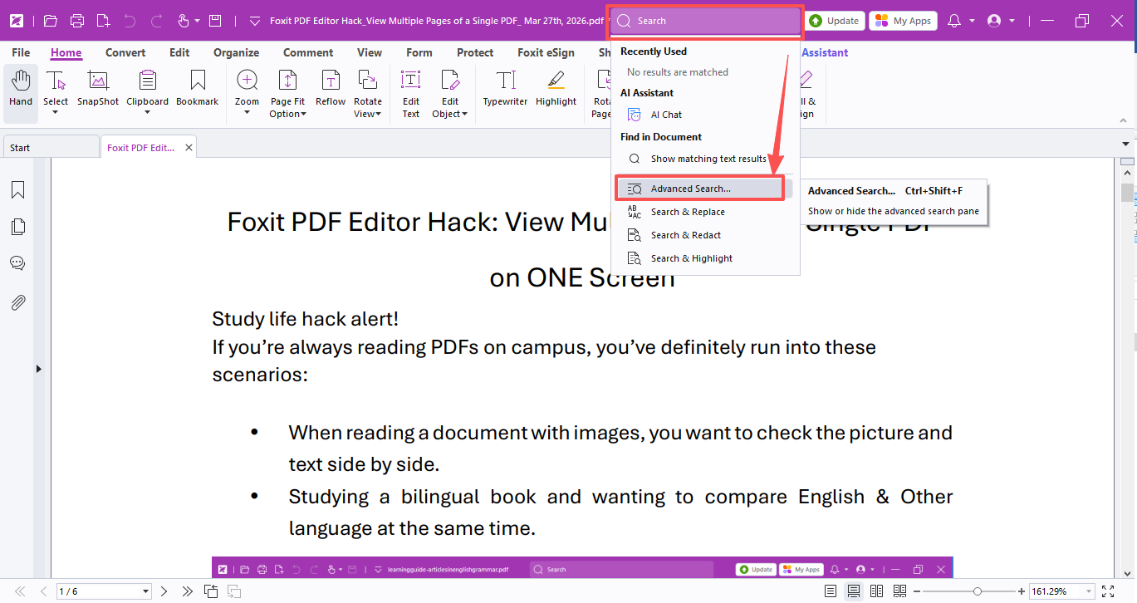

- Choose “Match any of the words”, type in your keywords, and hit “Search”!
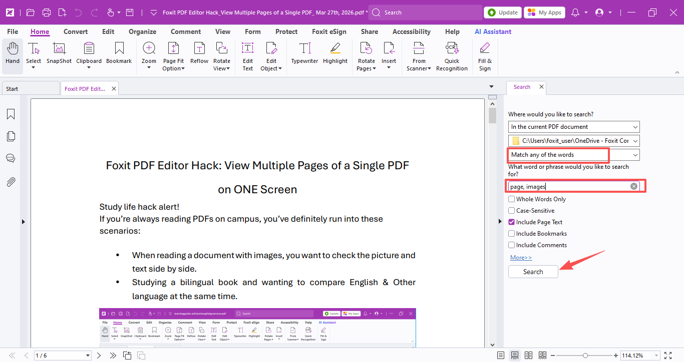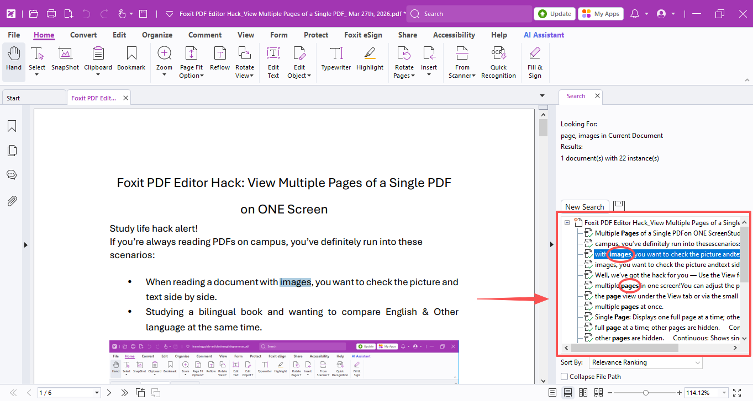

- To count the results, simply export them to a CSV file and open it in Excel.
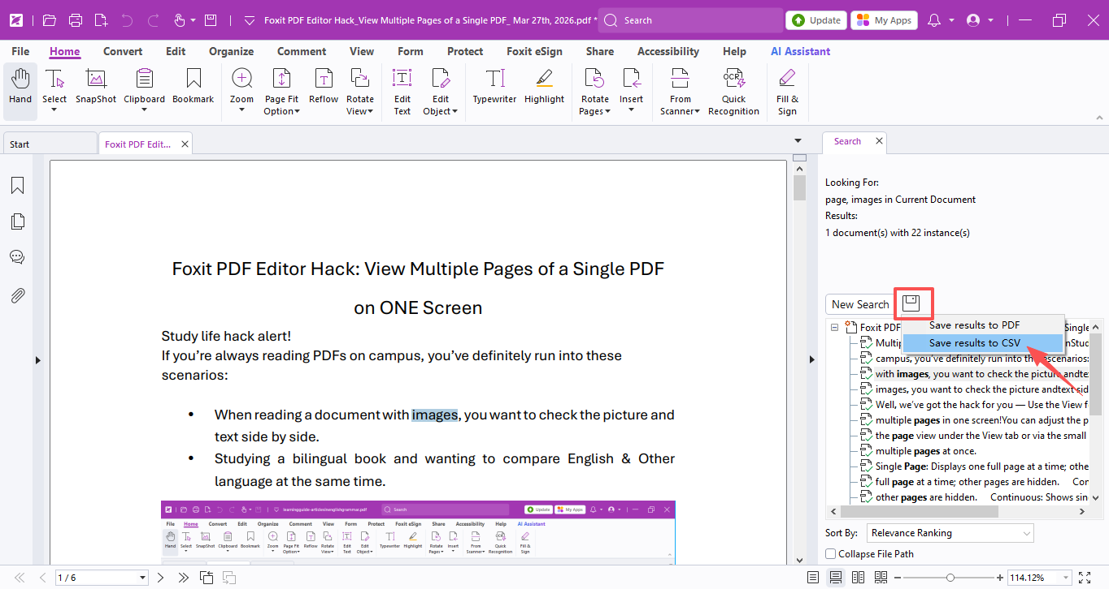
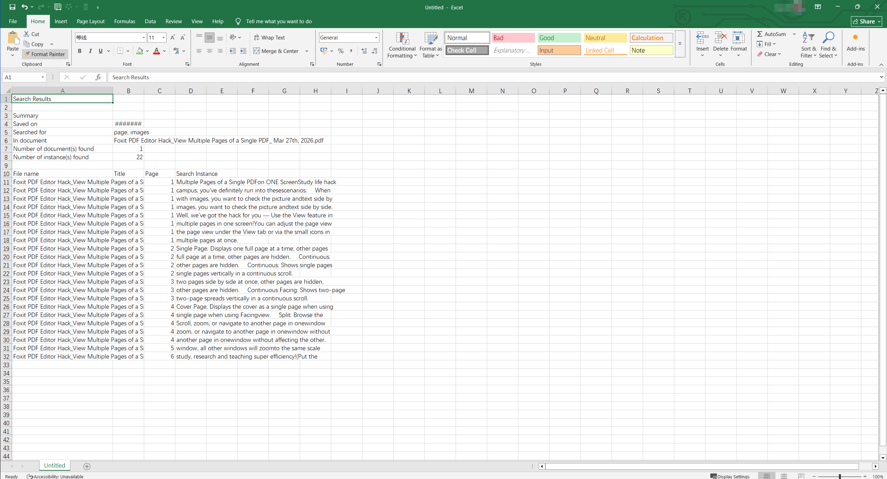
A quick tip:
This guide searches word by word, so if you want exact word or phrases, use “Match exact word or phrase” and search one word/ phrase at a time for better accuracy!
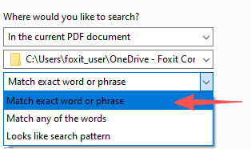

You can also search across multiple PDFs by adjusting the search range.
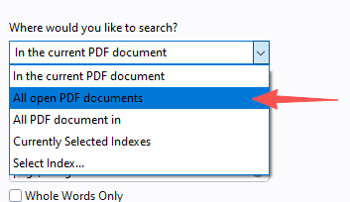

Hope this trick saves you lots of time and makes your study and work much easier!

See you next time with more handy PDF tips!

Grab the license right now!
(Put the license request links here)

If you have any questions about using Foxit PDF Editor, please feel free to click here to submit your inquiries. We will create dedicated guides based on your actual needs to provide further support.

